**Matthew Yeseta**

**Gen AI Architect**

**Here is how one must lead as a Gen AI Architect**

**Culture Team Development, Managing Performance Metrics**

As a Gen AI Architect, my focus is on leading with a people-first approach, where success is driven by empowering and recognizing the contributions of the entire team. I believe in fostering a culture of trust, continuous learning, and shared achievements, which is essential for sustaining long-term organizational success.

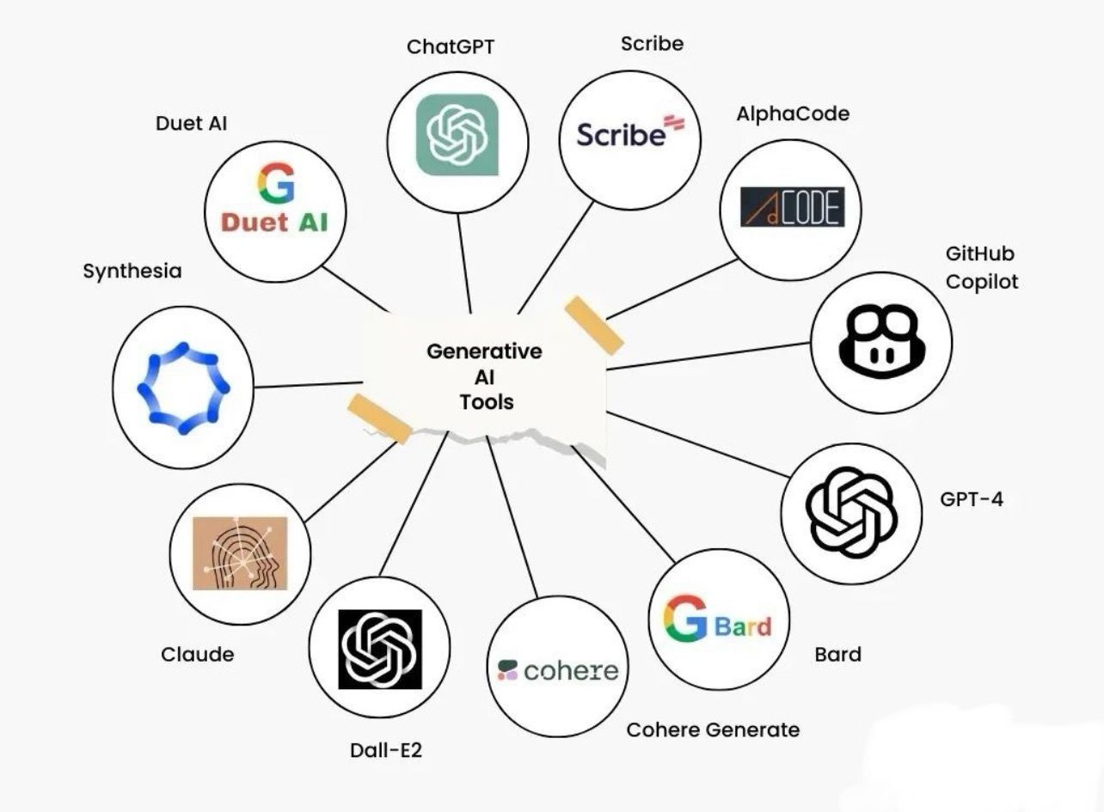

**Leadership in Team Development and Performance Management**  
Great engineering leadership transcends technical expertise; it thrives on people. Many teams lack managers who truly listen. Effective leadership starts by engaging the team in defining success and understanding their contributions to the organization. If your team isn’t empowered to make decisions, that’s a problem that needs fixing. If your team sees you taking credit for their work, then as a manager, you've failed them.  
  
As a leader, senior leadership is key to prioritize with my team and ensure that any achievements or recognition are directed towards them, not me. Without their efforts, I wouldn’t succeed alone. Manager need to believe in giving full credit to the team—it's the collective that wins or fails, not the individual. Building trust begins on day one by advocating for their empowerment, recognizing their achievements, and supporting their work-life balance. This approach is key to fostering a positive culture and sustaining long-term success.

**Managing Performance Metrics**  
  
Establishing clear KPIs and tracking progress ensures alignment with company goals. While managers can plan, they must collaborate with the team to determine the best times for status updates and reviews. Performance reviews should be conducted in comfortable settings, with a focus on clearing roadblocks and encouraging continuous improvement. Real-time feedback mechanisms are essential, keeping the team aligned with goals and ensuring their work adds value. In every success, I ensure the recognition goes to the team—they are the true achievers.

**Cultivating a Culture of Continuous Learning**  
  
Creating a culture of continuous learning is vital. As managers, it’s our passion to foster an environment where curiosity and experimentation thrive, making learning an integral part of work. Encouraging a growth mindset and promoting collaboration drive innovation. Recognize and reward knowledge sharing and open discussions about both successes and failures. Lead by example and embrace new ideas. By reinforcing a growth mindset across the organization, we lay the foundation for sustainable growth and innovation.